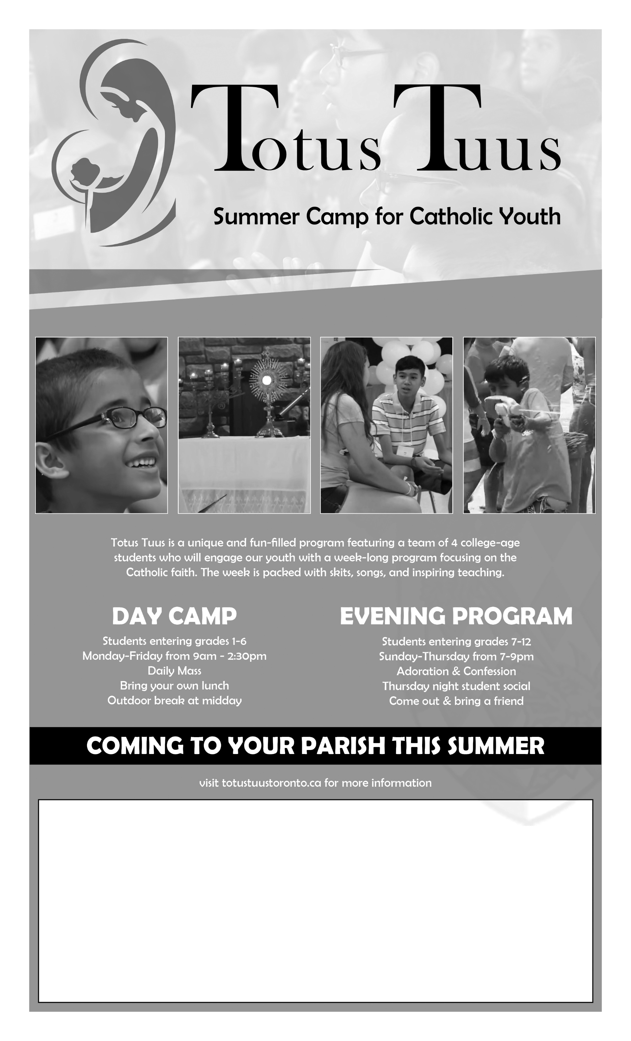

Totus Tuus for (parish name) will take place on: (date range)

Day Camp Registration Fee: ($ amount)

Evening Program Registration Fee: ($ amount)

To register, please contact (contact name and info)

